Data Analysis of Stroke Data

Virtual case background and tasks introduction

United Health Stroke Foundation (UHSF) is a global organisation that works with various government and non-government health organizations across the globe for minimizing stroke-related incidents, saving lives, designing educational and training material and enhancing the recovery of stroke victims. United Health Stroke Foundation (UHSF) has Headquartered in Geneva, Switzerland, and has regional offices in London, New York, Singapore, and Sydney. The Foundation prides itself on its mission to identify and remove barriers to health care access and quality, advance cardiovascular health for all, and support survivors of stroke and their families, healthcare professionals and researchers to build community awareness and foster new thinking.

UHSF relies on data it collects from different countries to understand the patterns, drivers, and factors related to stroke incidents. As the research and various scientific publications have frequently cited personal, health, and lifestyle-related factors, in understanding stroke incidents, UHSF undertook a study over a period of 10 years from 2010 to 2020 to identify the various factors that might relate to the occurrence of stroke. Approximately 20,000 people from different regions and geographies, at various points in time, were invited to participate in this study and personal information, health indicators, lifestyle choices etc, were collected from the individuals. The stroke data spans sixteen variables and is stored as a CSV file “healthcare-dataset-stroke-data.csv”. The variables are summarized below (check the data dictionary for a detailed description of the data).

- Personal - Gender, Age, Occupation, Marital Status, Work Type
- Health Indicators - Heart Disease, Average Glucose Level, Body Mass Index, Cholesterol level
- Lifestyle Choices - Smoking Status, Alcohol Consumption, Residence Type
- Others - Participant ID, Continent, Year of Participation, Stroke (Yes/No)

The UHSF executive would like to understand the relationship between various variables with stroke, compare the variables, and understand the composition and the underlying distribution of the stroke-related factors. At a recent conference, executives of UHSF learned the power of data visualization and how data visualization can be used to communicate interesting insights from the data. The executives have been recommended to use Power BI to convert the data to analytic-friendly forms, create insightful dashboards and reports, perform visual analytics, and present it in a way that helps them to formulate communication messages and design intervention strategies.

The data visualization should be applied based on the knowledge and skills to produce visual reports that highlight key insights from the data and communicate your results in an academic style report. In particular, UHSF executives are interested in discovering factors associated with stroke incidents. Also, the most important factors associated with increased risk of stroke and the relationship between these variables are identified.

- Executive Summary:

This report uses graphs based on given data and then explores the association between the risk of having a stroke and various factors. Those factors explored and reflected upon include personal information, health status, lifestyle. In order to consider and examine the possible causes of stroke from a macro perspective, e.g., continents and overall time lapse. Based on the visual graphical analysis and the references, it is known that older age, overweight, stressful life, glycemic index, smoking and drinking habits are more likely to cause strokes. In addition, being male, living in a rural area, and being a private worker are also more likely to have a stroke than people in other situations. The probability of heart disease is also higher in the stroke population. In addition, the number of people with stroke on each continent has remained largely declining or flat over the decade from 2010. Overall, the number of stroke patients is trending downward compared to the past.

At the end of the paper, other potential risks that may lead to stroke, some signs before the onset of stroke and some effective measures to avoid its occurrence are also discussed briefly.

Descriptive analysis of Stroke via PBI

  - The two most important/relevant relationships between stroke and factors related to personal information.
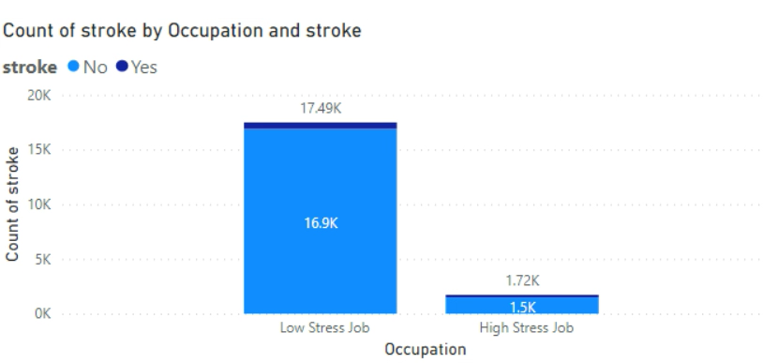
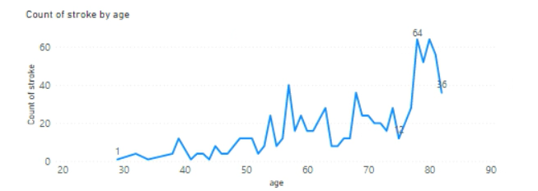

Findings: 1) among respondents who had a stroke, the proportion of people who were stressed at work was greater than the proportion who were stressed at work without having had a stroke; 2) the number of strokes is directly proportional to age.

Justify choices: Prolonged stress directly increases the probability of having a stroke [1]. The probability of stroke increases somewhat with age, also it is still a disease that can strike for any age group [2].

  - The two most important/relevant relationships between stroke and factors related to health Indicators.

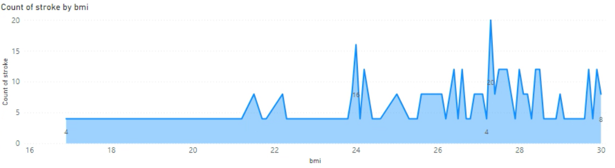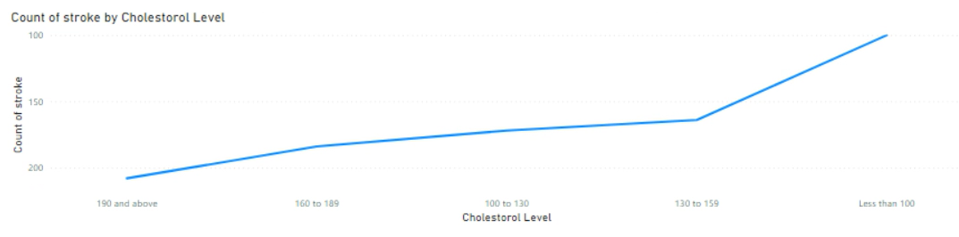

Findings: 1) overweight people are more likely to have a stroke; 2) when the Cholesterol level is higher, the chance of stroke becomes greater.

Justify choices: it is easy to draw the above conclusions from the interval distribution of the two graphs above. Also, BMI as an important index of body mass, overweight will directly enhance the risk of chronic diseases like stroke [3]. BMI is 25 to 29.9 will be considered as overweight [4]. Excessive high cholesterol level can lead to an increased likelihood of developing a stroke [5].

  - Compare the Lifestyle Choices factors based on the association with stroke.

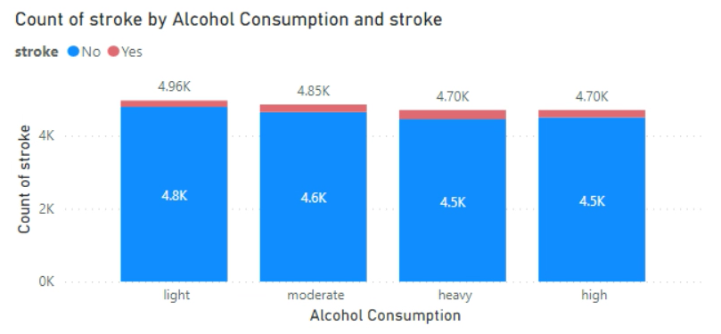
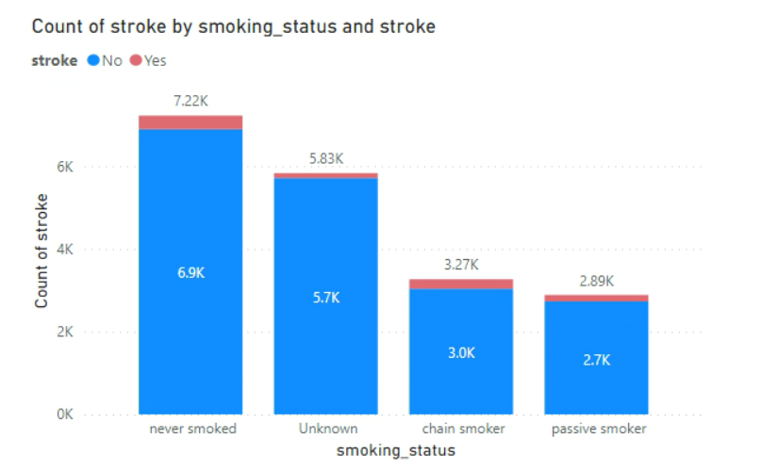

Findings: 1) for participants who have a drinking habit, the more they drink, the greater chance strokes they will have; 2) for the population surveyed, the smoking population (active and passive smokers) accounted for a larger proportion of the overall number of stroke patients than those who smoked among those who had not suffered a stroke.

Justify choices: the risk of having a stroke may increase with increased alcohol intake [6]. Also, smoking cigarettes would directly increase the risk of getting various heart diseases and also stroke [7].

  - The trends of stroke incidents across the different continents

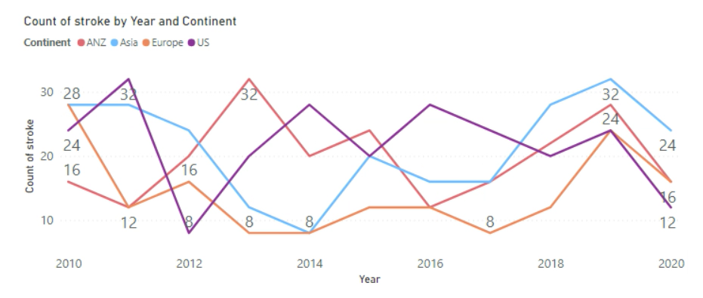

Findings: from a macro perspective, the number of stroke patients across all continents shows an overall decrease or flat number during the decade in this one decade.

Justify choices: according to the line chart above, although there are varying degrees of increase or decrease in each continent during this decade, it is undeniable that the number of stroke patients in 2020 is smaller or equal to the number of patients they each had in 2010. There seems to be better awareness and greater education about how to prevent measures for cardiovascular diseases (such as stroke) globally than ever before.

  - A PowerBI dashboard report to summarize the important findings.

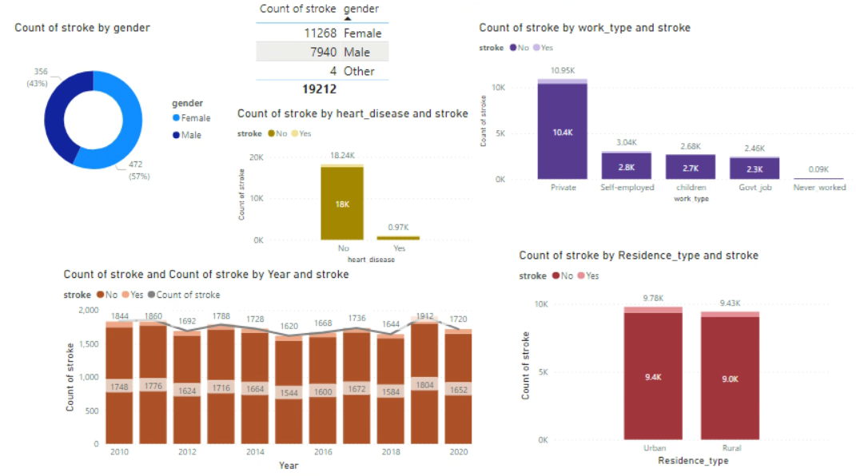
Findings: 1) overall downward trend in the number of stroke patients in this decade; 2) male are more likely to have a stroke; 3) stroke patients are more likely to have heart disease; 4) private workers and people who live in rural areas are more likely to have a stroke.

Justify choices: although there is an upward or downward trend in between, the overall number of stroke patients in 2020 is lower compared to 2010. Stroke prevalence is higher in men before age 80 [8]. Living in rural areas may lead to a greater susceptibility to stroke [9].

Discussion of the Results and conclusions

In addition to the various factors discussed above (in section 2.1 - 2.4) that can increase the risk of stroke, other common factors include some hormonal medications, diabetes, a history of stroke in family members, high blood pressure, and a sedentary lifestyle [10][11]. Stroke can affect every aspect of life, such as physical coordination and control as well as mood and personality changes [12].

Now here are some effective approaches that could prevent a stroke. It is especially important when enabling citizens to understand the possible consequences of a stroke and the potential factors that can lead to it. First of all, promoting the importance of regular health checks (e.g., regular blood pressure, blood sugar and heart rate measurements) can effectively reduce the chance of stroke due to diabetes or high blood pressure, hyperglycemia and heart disease. In addition, educating citizens to discipline and manage their daily habits. Maintaining a well-balanced diet and abstaining from alcohol would be among the common dietary management methods. Quitting smoking and maintaining a fitness routine are equally effective and important preventive measures.

Based on the discussion and findings in section 2.4, it is important to focus on two continents ANZ and Asia in addition to the information and education activities that can be carried out for the general public. The graphs show signs of a flat and negligible decrease in the number of stroke patients respectively, during the decade from 2010 to 2020.

Helping people worldwide build awareness to prevent cardiovascular disease or stroke is the only way to prevent it before it happens. Also, according to the results of section 2.5, the incidence of stroke is likely to be effectively curbed and gradually decreased in the future. >>

References

- “Can Stress Cause a Stroke? Yes, and Here’s What You Can Do,” Flint Rehab, Jul. 13, 2021. https://www.flintrehab.com/can-stress-cause-a-stroke/#:~:text=The%20biggest%20reason%20why%20stress%20leads%20to%20stroke
- “What is a stroke?,” Stroke Foundation - Australia. https://strokefoundation.org.au/about-stroke/learn/what-is-a-stroke#:~:text=Stroke%20can%20happen%20at%20any%20age.%20Childhood%20stroke
- “Heart, stroke and vascular disease—Australian facts, Overweight and obesity,” Australian Institute of Health and Welfare. https://www.aihw.gov.au/reports/heart-stroke-vascular-diseases/hsvd-facts/contents/risk-factors/overweight-and-obesity
- “Normal Weight Ranges: Body Mass Index (BMI),” www.cancer.org. https://www.cancer.org/healthy/cancer-causes/diet-physical-activity/body-weight-and-cancer-risk/adult-bmi.html‌
- “Can High Cholesterol Cause a Stroke?,” Healthline, Jan. 13, 2022. https://www.healthline.com/health/high-cholesterol/how-high-cholesterol-levels-can-increase-your-stroke-risk‌
- “Does drinking alcohol raise the risk of stroke?,” Harvard Health, Jul. 01, 2019. https://www.health.harvard.edu/heart-health/does-drinking-alcohol-raise-the-risk-of-stroke‌
- R. S. Shah and J. W. Cole, “Smoking and stroke: the more you smoke the more you stroke,” Expert Review of Cardiovascular Therapy, vol. 8, no. 7, pp. 917–932, Jul. 2010, doi: 10.1586/erc.10.56.
- T. B. Wyller, “Stroke and gender,” The journal of gender-specific medicine: JGSM: the official journal of the Partnership for Women’s Health at Columbia, vol. 2, no. 3, pp. 41–45, May 1999, Accessed: Oct. 09, 2022. [Online]. Available: https://pubmed.ncbi.nlm.nih.gov/11252851/#:~:text=Stroke%20and%20gender%20The%20literature%20regarding%20gender-specific%20aspects
- M. K. Kapral et al., “Rural-Urban Differences in Stroke Risk Factors, Incidence, and Mortality in People With and Without Prior Stroke,” Circulation: Cardiovascular Quality and Outcomes, vol. 12, no. 2, Feb. 2019, doi: 10.1161/circoutcomes.118.004973.
- S. Davis, “Top Causes of Stroke,” WebMD, Jun. 30, 2011. https://www.webmd.com/stroke/guide/stroke-causes-risks‌
- “MSN,” www.msn.com. https://www.msn.com/en-au/health/condition/stroke?ocid=entnewsntp
- Stroke Foundation, “Effects of stroke — Stroke Foundation - Australia,” strokefoundation.org.au. https://strokefoundation.org.au/About-Stroke/Learn/Effects-of-stroke‌
- L. Li, C. A. Scott, and P. M. Rothwell, “Trends in Stroke Incidence in High-Income Countries in the 21st Century,” Stroke, vol. 51, no. 5, pp. 1372–1380, May 2020, doi: 10.1161/strokeaha.119.028484. >>

